Danse orientale
New Beginner Level classes 8 wk session
Starting FEB 2026
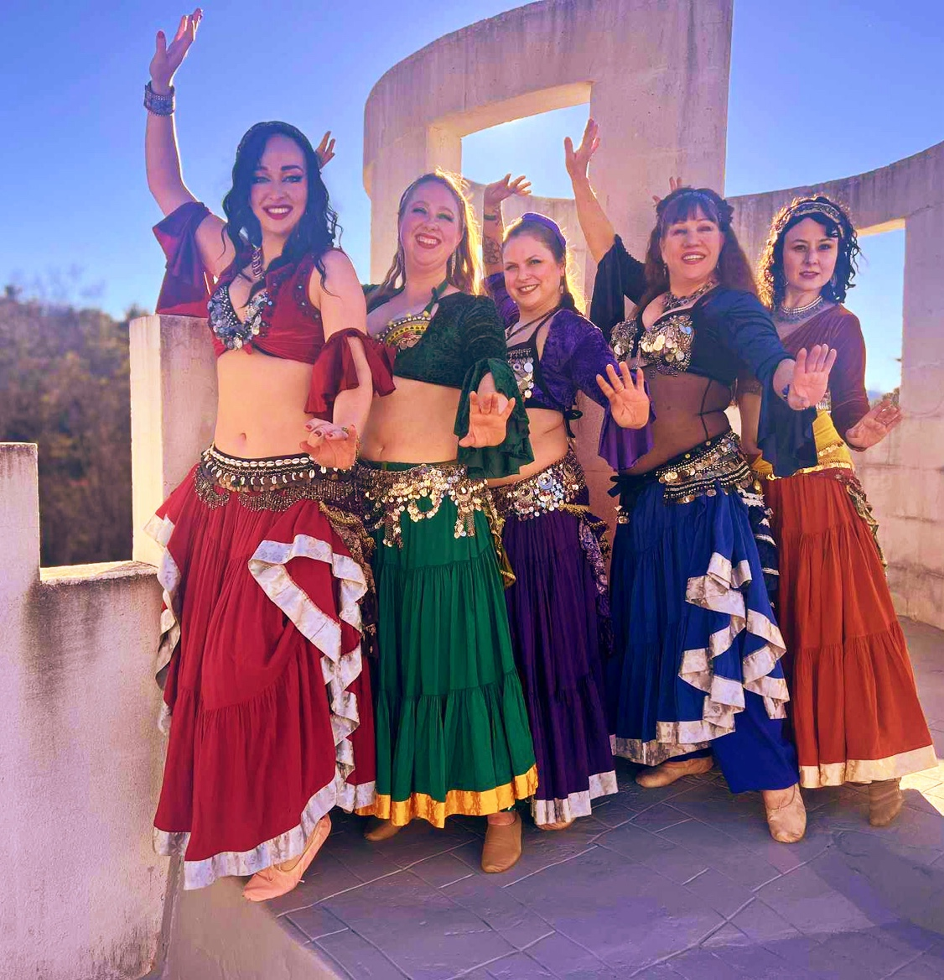
$120.00 TUESDAYS 7pm-8:30 pm
Taught by Ginny King 404-245-6344 Sautee /Ariel locale
Choreography and improv techniques .Belly exposure is not required
https://sauteeschoolofdance.com/belly-dance/

